Problems and questions:

Using an Internet search, what are X-Content-Type-Options and X-Frame-Options headers, and how might the protect your site? Using an Internet search, what are X-frame-option headers? What are typical applications of SQL Injection attacks (what actions can an attacker perform)?
X-Content-Type-Options and X-Frame-Options are HTTP security headers that help protect web applications from common browser-based attacks.
- X-Content-Type-Options: nosniff prevents browsers from guessing (MIME-sniffing) the content type of a response, forcing them to respect the declared Content-Type. This reduces the risk of malicious files being interpreted as executable scripts.
- X-Frame-Options controls whether a page can be embedded in an <iframe>, helping prevent clickjacking attacks. With values like DENY or SAMEORIGIN, it blocks attackers from framing a site on a malicious page and tricking users into interacting with hidden elements.
- Modern applications often use Content-Security-Policy: frame-ancestors as a more flexible replacement.
SQL Injection (SQLi) attacks exploit improper handling of user input in database queries.
Through SQLi, attackers can extract sensitive data such as credentials and personal information, bypass authentication mechanisms, and modify or delete database contents. In more severe cases, they can execute administrative database commands, escalate privileges, or perform blind SQLi to infer data through response behavior.

Why is it important to keep the data validation rule on both client and server sides?
Client-side validation:
- Improves user experience: immediate feedback, less round-trips.
- Reduces garbage requests to server.
Server-side validation (must always exist):
- Security-critical: clients can be bypassed (malicious users, altered clients, automated scripts). Server must not trust any client input.
- Ensures data integrity, prevents injection attacks, enforces business rules.
Combined: client-side validation is convenience; server-side is enforcement. Always implement both; never rely on client-only checks.

How to restrict access to resources to which the user has no permission?
Key controls and best practices:
- Authentication
  - Strong authentication (secure session cookies, JWTs with proper verification).
  - Secure cookie flags: HttpOnly, Secure, SameSite.
- Authorization (server-side enforced)
  - Implement RBAC (role-based access control) or ABAC (attribute-based).
  - Server must check authorization on every request for protected resources — deny by default.
  - Avoid client-controlled privilege fields. Assign roles server-side.
- Direct Object Reference protections
  - Avoid predictable sequential IDs. Use opaque references (UUIDs, mapping tokens) or verify ownership.
  - Always check that the authenticated user owns or has rights to the requested object.
- Least privilege
  - Give users the minimum permissions required.
  - Run services with minimal OS/db privileges to limit damage from compromise.
- Input validation & encoding
  - Prevent injection that could bypass access controls (SQLi, NoSQLi, command injection).
  - Use prepared statements / parameterized queries.
- Secure APIs
  - Use proper access control checks inside API endpoints (not only in UI).
  - Enforce scope on tokens and sessions.
- Logging & monitoring
  - Log access attempts and suspicious activity and alert on anomalies.
- Rate limiting & brute-force protection
  - Prevent enumeration and automated attacks.
- Use proven frameworks / libraries
  - Don’t roll your own auth/ACL logic if good libraries exist.

Open the web:

Open terminal, go to the JuiceShop folder (on the Desktop) and execute:
> npm start
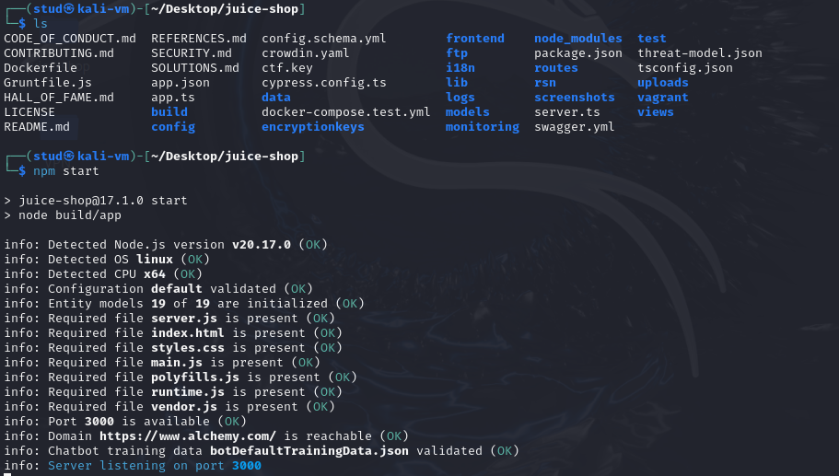
> npm start: Runs the start script of a Node.js project.

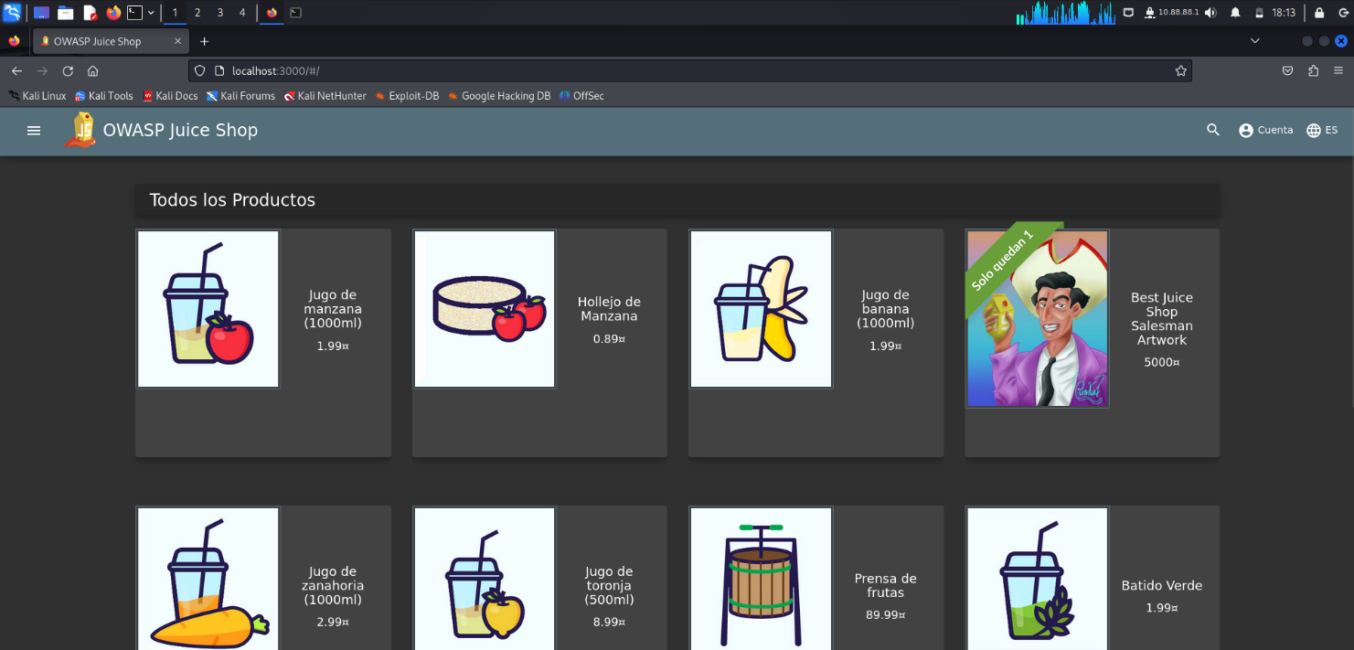
Open browser and use address: localhost:3000
Please remember that JuiceShop with default configuration restores the database to its initial state every time it is started!

Security Misconfiguration:

Open OWASP ZAP:
Open in Kali from the apps: ZAP (Zed Attack Proxy) is a free, open-source web application security scanner and dynamic application security testing tool developed by the Open Web Application Security Project (OWASP).
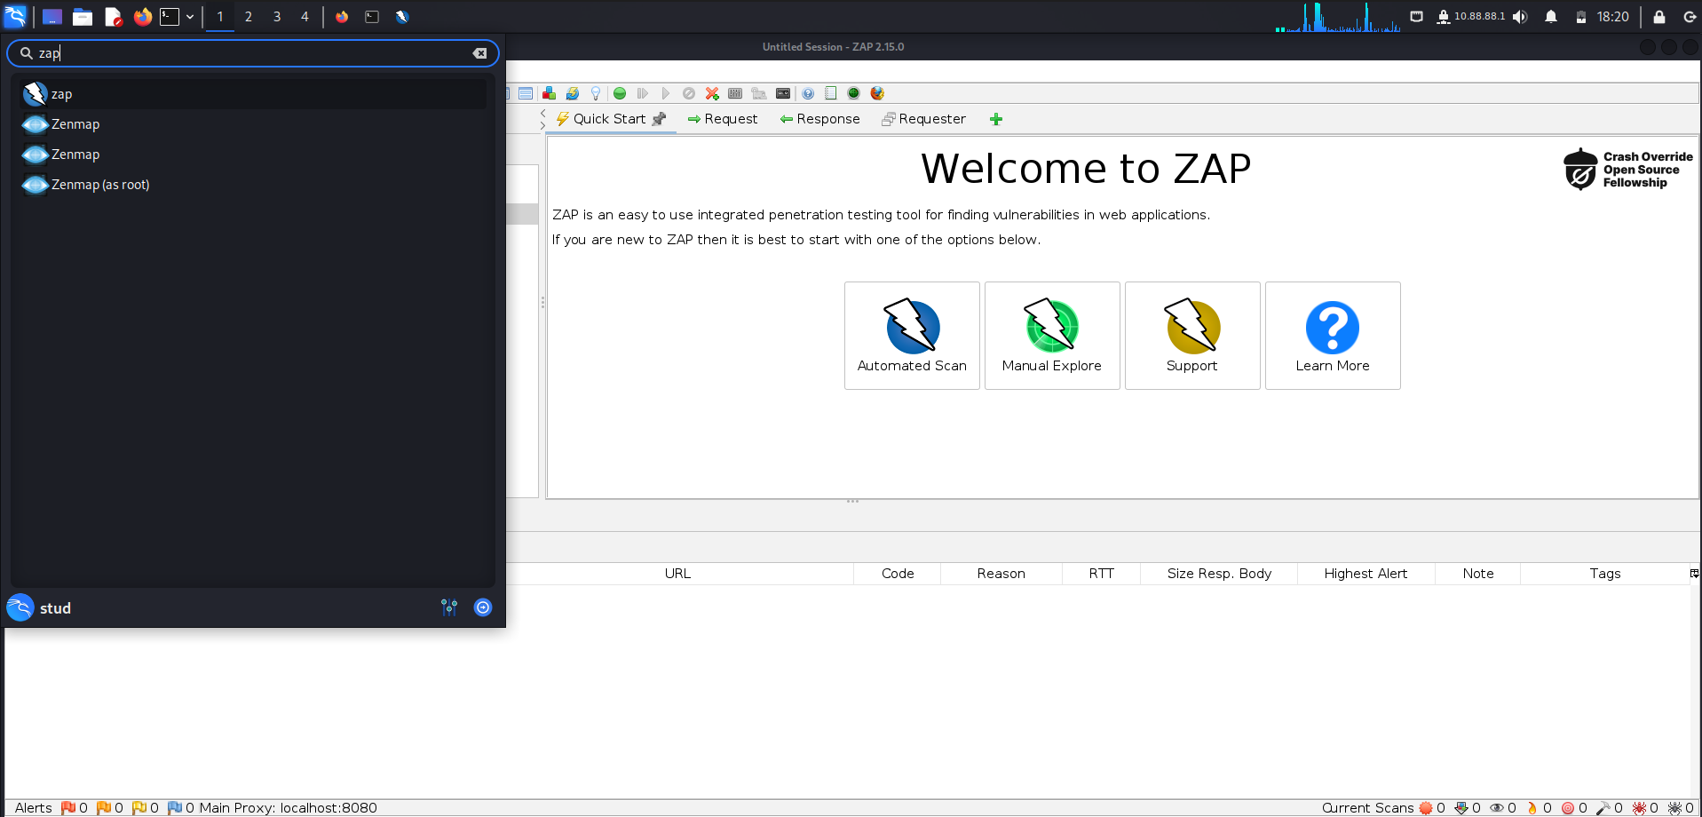

Scan for the JuiceShop site.
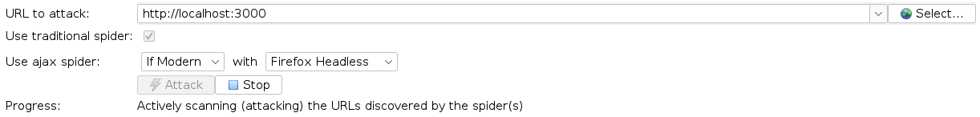
Search for: http://localhost:3000 and click Attack.

After the scan answer the questions:
How many flags did it raise for:Red flag, Amber flag,Yellow flag,Blue flags. What directories has it exposed that can be browsed?
Can you browse them (try with web browser)?
What cookie information risk has been discovered?
After scanning the hole page, we got:
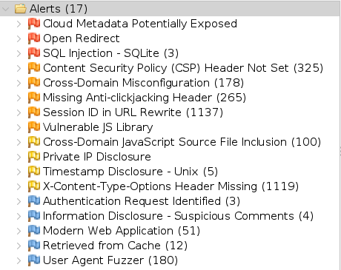
ZAP reported ≈5 red (high) instances across 3 high-risk types (SQLi - 3 instances, Open Redirect, Cloud Metadata), ≈3,124 amber (medium) instances (mostly missing security headers like CSP, X-Content-Type-Options, anti-clickjacking, session-in-URL and cross-domain/script issues), ≈6 yellow (low) instances (timestamp and private IP disclosures) and ≈250 blue (info) instances (fuzzer hits, cached responses, modern-app info, suspicious comments).
By opening the left panel, we can see the structure of the web with lots of directories as api, assets, …:
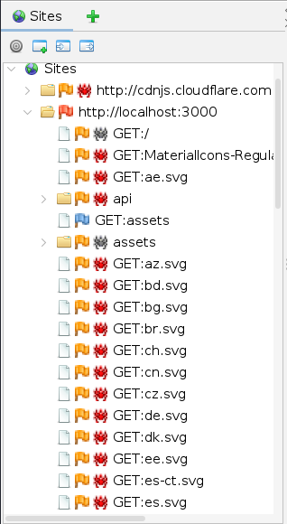
We can check the structure of the page, that is a bad thing:
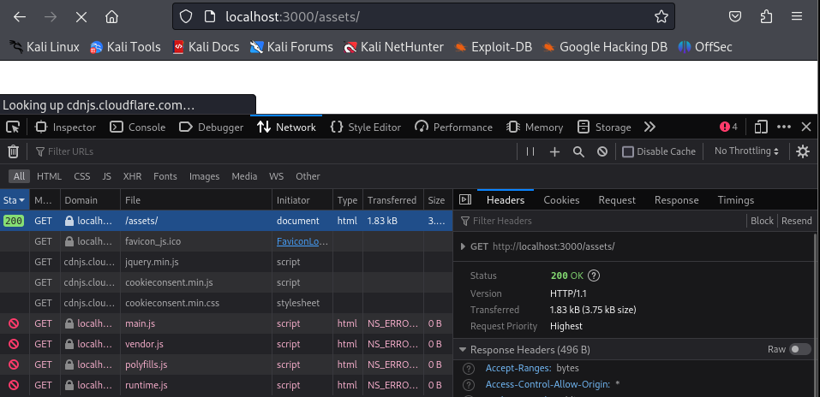
We can see in the image that the request status was 200 (OK) so it is valid.
To get any more visual confirmation we can access any content by for example opening:
> http://localhost:3000/assets/i18n/en.json
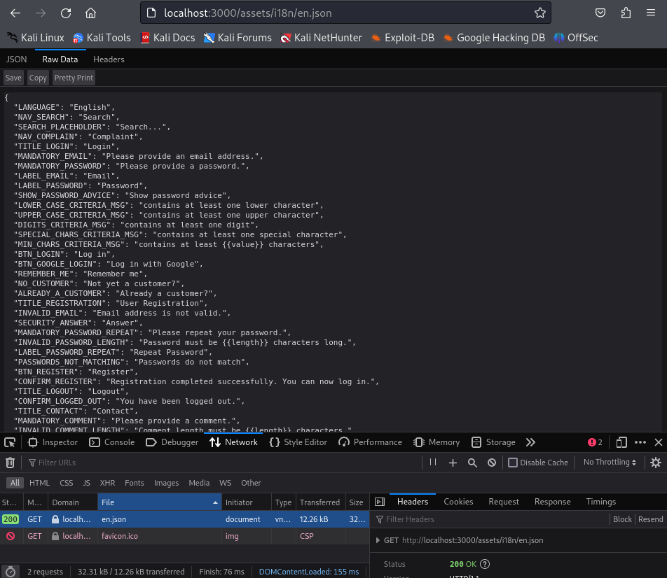
No explicit cookie-flag alerts were raised by ZAP. However, ZAP identified extensive session handling issues, notably ‘Session ID in URL Rewrite’, indicating session identifiers are exposed via URLs instead of secure cookies. This presents a higher risk than missing cookie flags, as session IDs can be leaked through logs, browser history, and referrer headers.
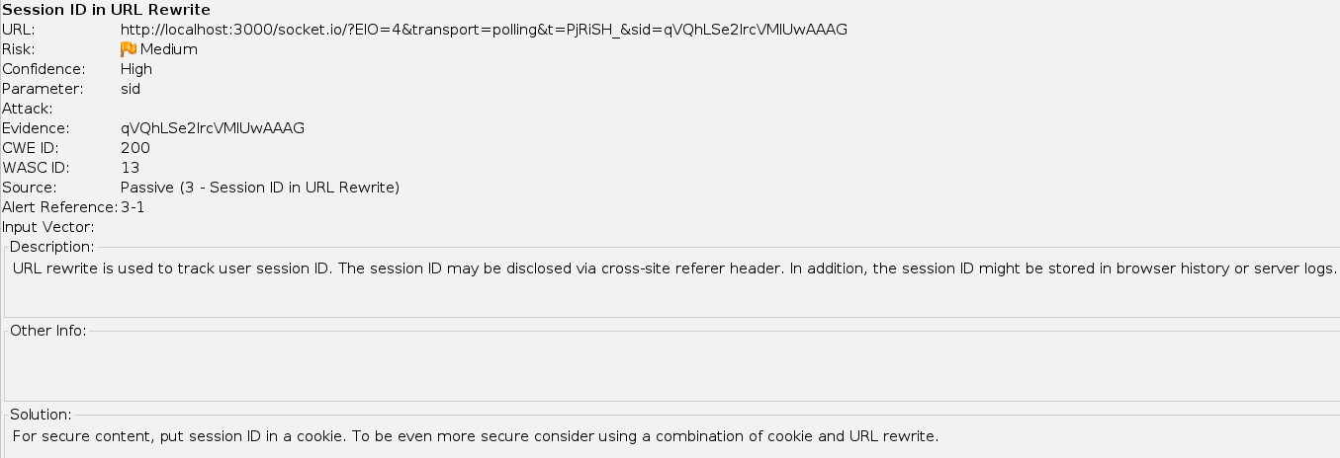
Improper input validation is evidenced by ZAP detecting multiple SQL Injection vulnerabilities and an Open Redirect, indicating that user-supplied input is not properly sanitized or constrained before being processed by backend logic.

Improper Input Validation:

Check proxy settings in ZAP (Options -> Write “Proxy” in Search Field):
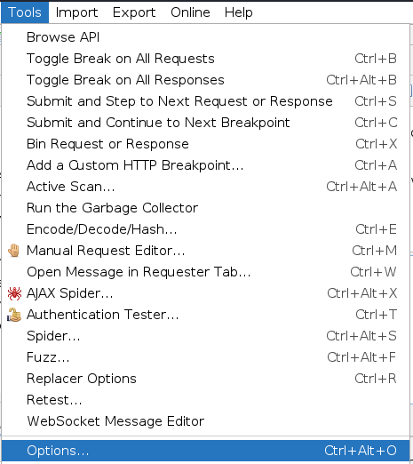
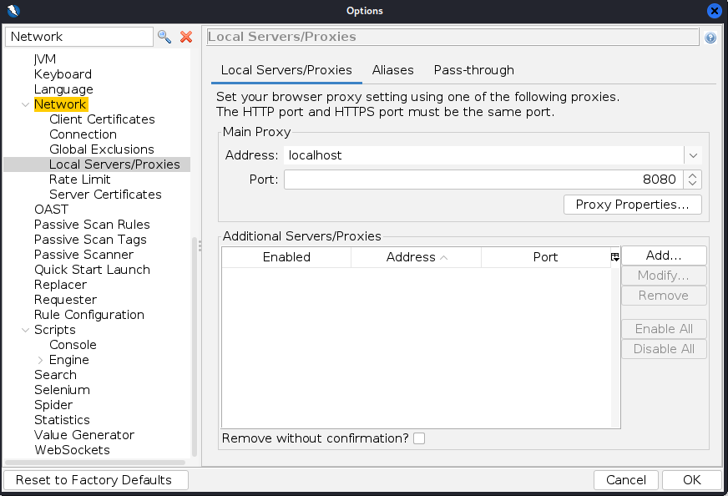
Go to Tools -> Options, search for Network -> Local Servers/Proxies

Configure the Firefox in Kali VM (Preferences -> Write “Proxy” in Search Field) – Provide the same data as in ZAP:
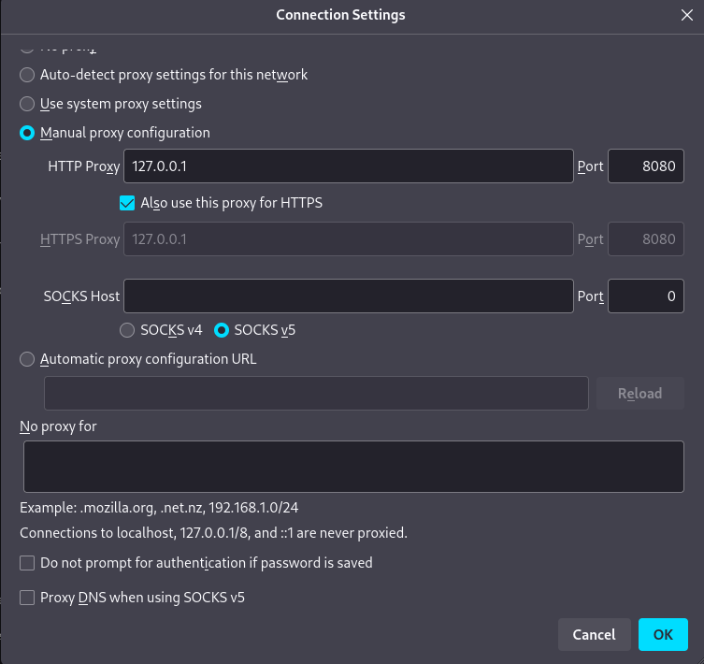
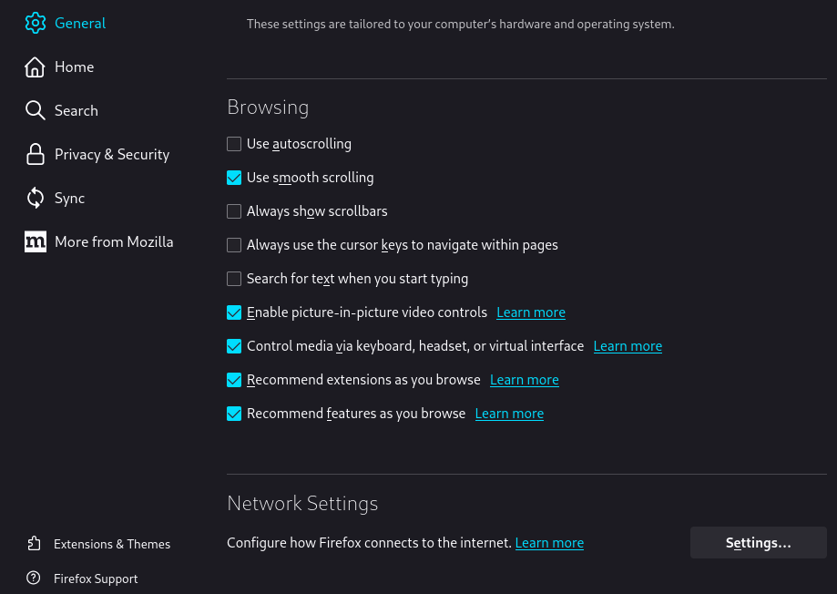
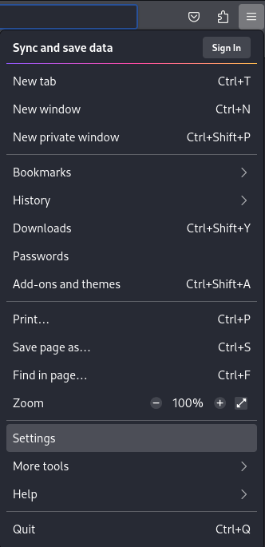
Go to settings -> Network Settings:

Look if needed at the tutorial: https://techofide.com/blogs/setting-up-owasp-zap-as-a-proxy-for-your-browser-and-performing-a-vulnerability-scan/
Also follow the tutorial (useful in 5.1/2/3): https://youtu.be/YRngT1fP1JA?si=m937GfW0IY2JrvTY

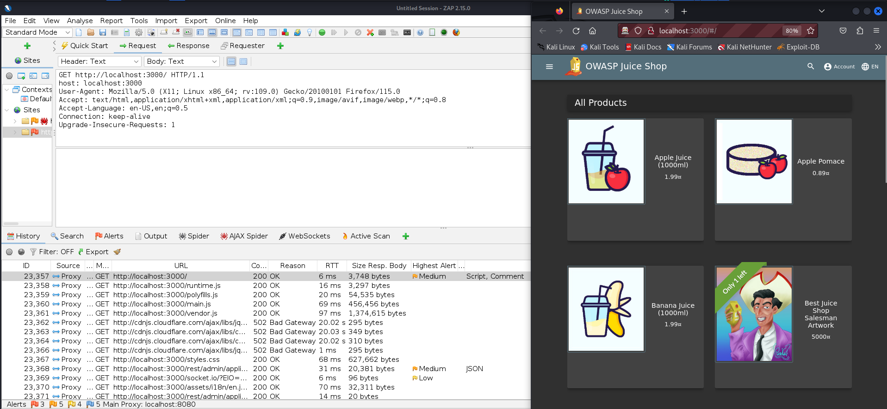
Open JuiceShop main page and check if it presents in ZAP history: Alternatively, you can start a session for ZAP in Firefox by clicking on the Firefox icon in the ZAP interface

As in the History tab the traffic appears all is configured fine.

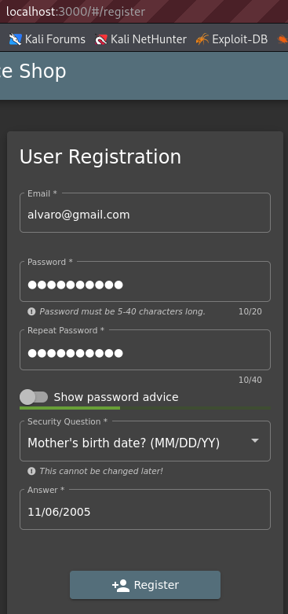
Go to juiceshop.domain/#/register , register new user and select “Mother’s birth date? (MM/DD/YY)’ as Security question (provide any valid date):
After registering, with:
Email: alvaro@gmail.com
Password: contrasena
Answer: 11/06/2005

Check the request and response for user registration (is there any parameter releted to admin?):
There were 3 messages created:
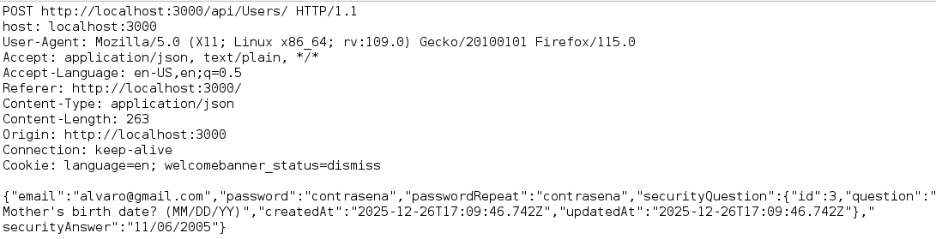
REQUEST:
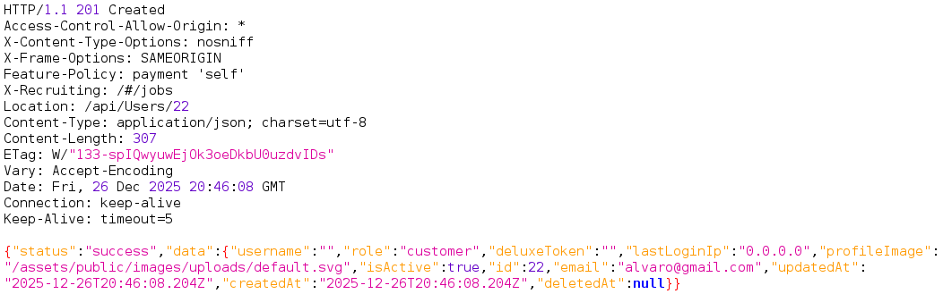
RESPONSE:

We can see in the POST response from /api/Users, the tag “role”: “customer”
If we can modify that role, something may happen. Lets check.

Select registration request and send it to the Request Editor (Right mouse click -> Open/Resend with Request Editor):
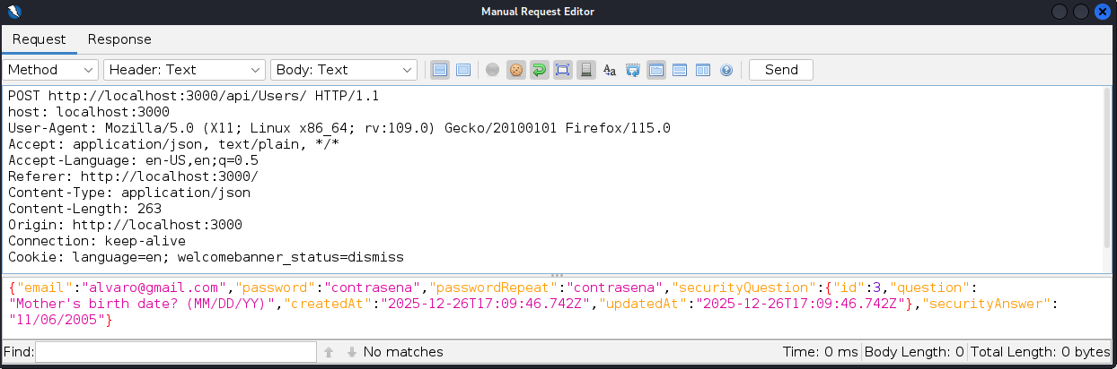
Right click on the POST /api/Users/ and later in: 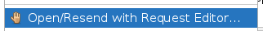

Modify the request (remember to change email) to register new user as admin (set role parameter):
By changing the email to alvaro1@gmail.com and adding the role tag and sending the request:

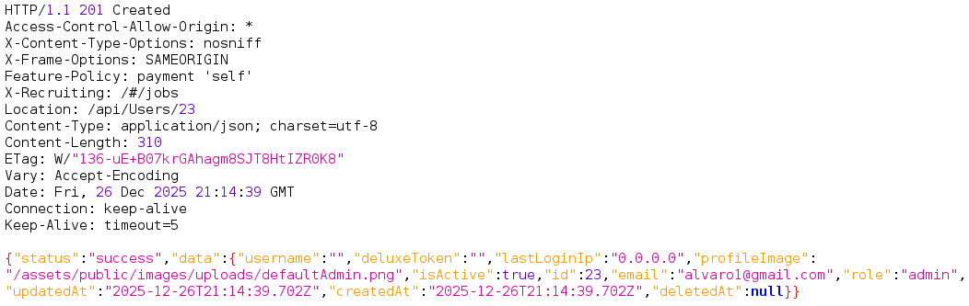
The user with admin role was created:

Execute in terminal:
sudo apt install snapd (restart virtual machine after this step)
sudo systemctl enable --now snapd apparmor
sudo snap install postman
postman
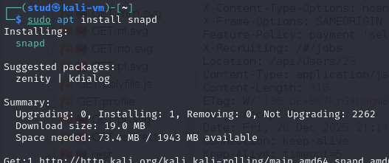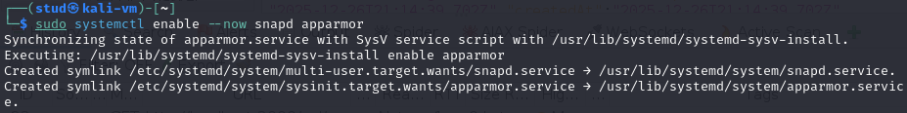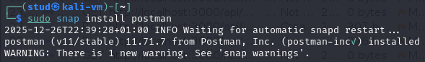
If I want to remove the postman in a future I should run: > sudo snap remove postman

Open Complaint subpage in browser:
Once logged in: > http://localhost:3000/#/complain
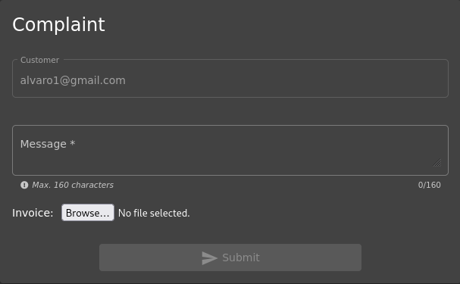

Try to upload a few .pdf files (<100kB, 100-200kB, >200kB):
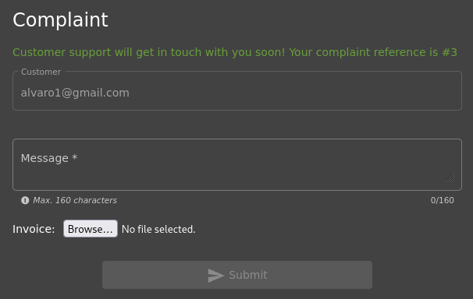
The front end only allows files <100kB so I can only add the first file from this part:

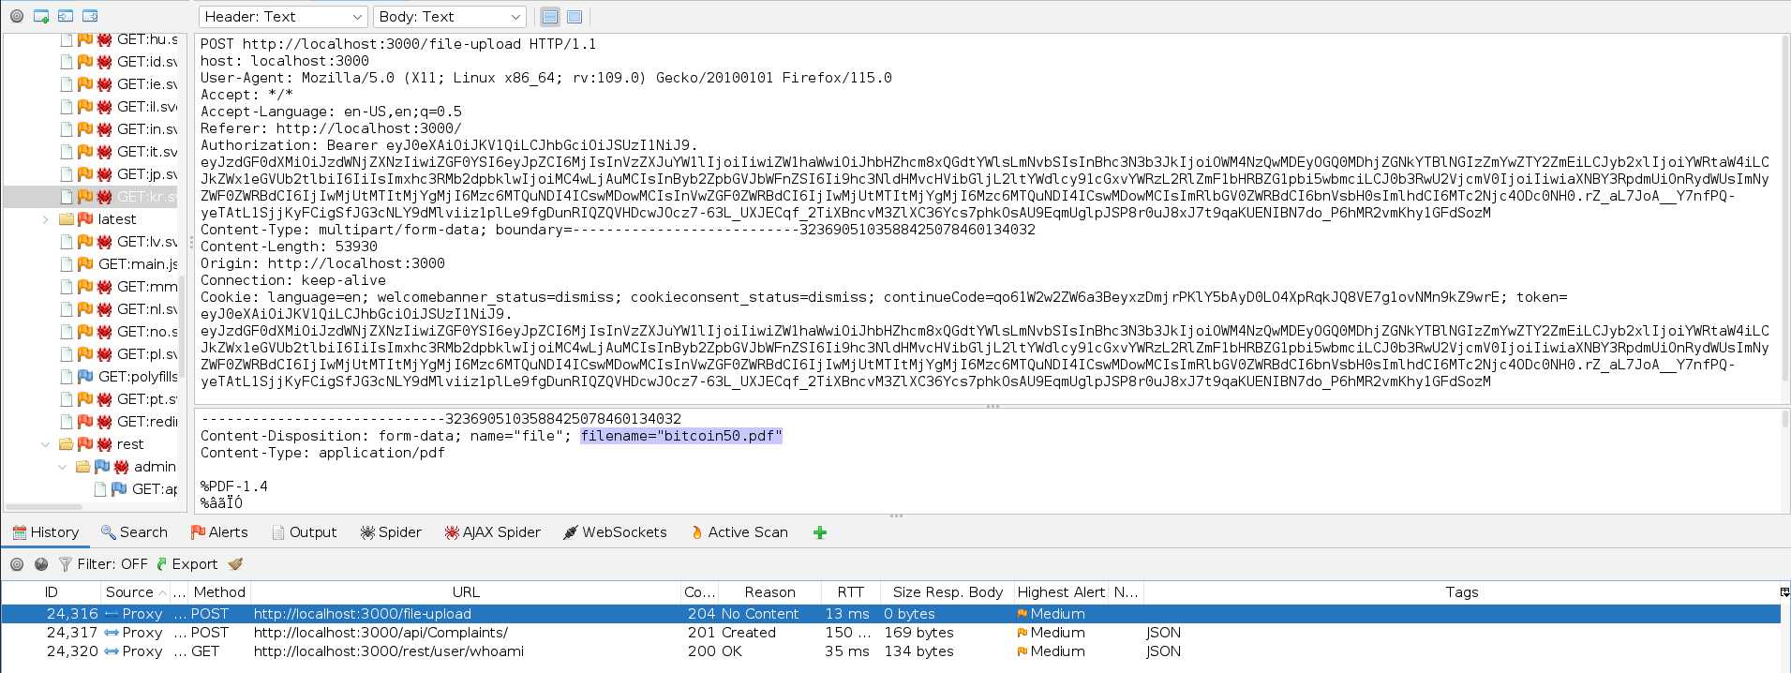
Catch the request for uploading <100kB pdf file in ZAP:

Change the content of the uploaded file in Request Editor to the content of the 100-200kB file. You have to open pdf in text editor, copy the content and exchange it with the data between %PDF and %%EOF flags, Alternatively, you can use Postman to create a similar request:
Set method type to POST
Body -> form-data -> Enter your parameter name ‘file’
Change parameter type to file and select a file which you want to upload
Open: /snap/bin/postman
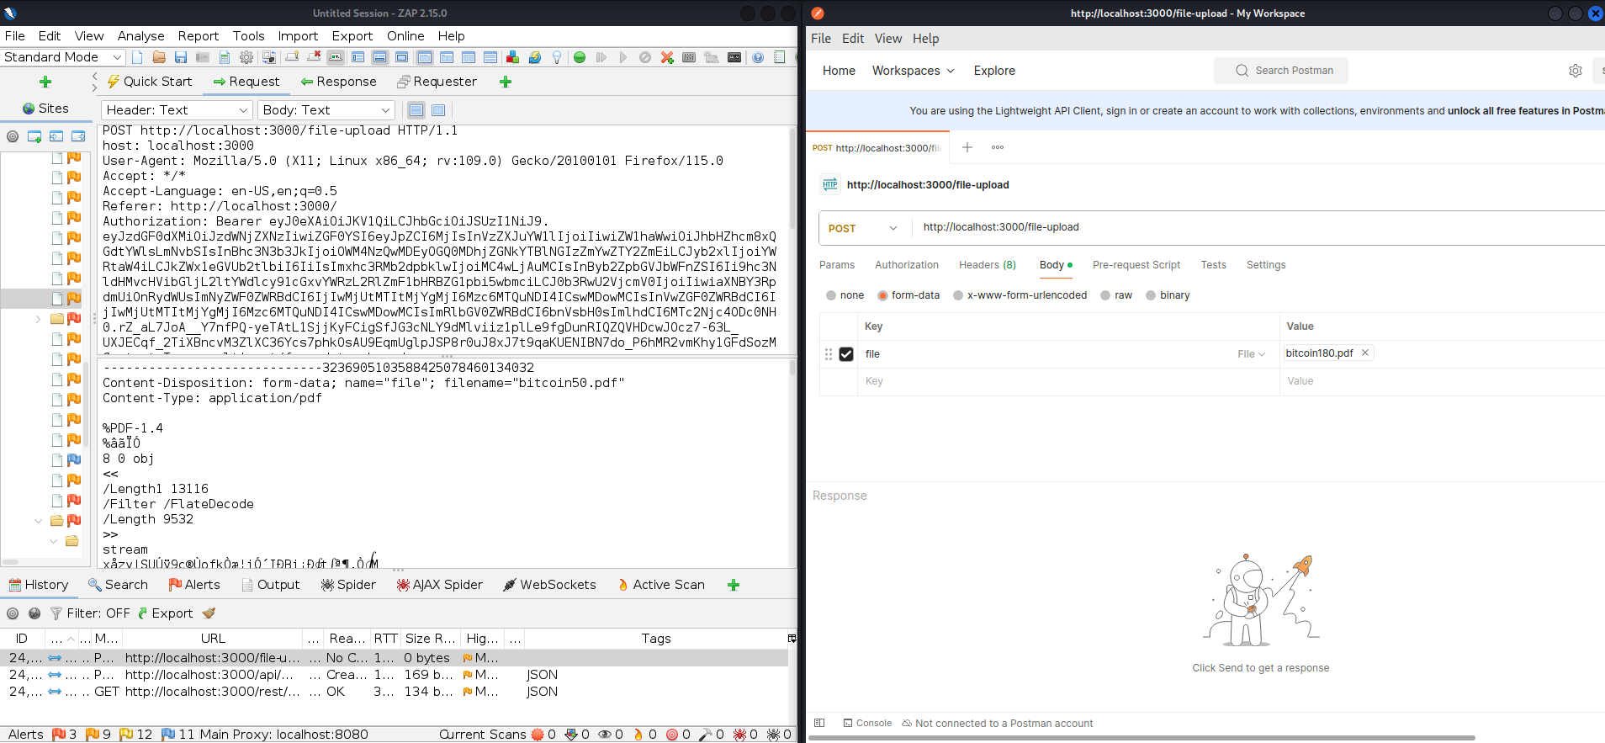
After adding the File (100-200 kB) and clicking on Send, the request is sent:
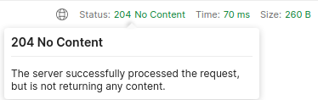
As the server does not reject it, there is no server-side validation, a bad thing in webs.
Any can bypass the security of the UI and send larger files than the expected ones.

Repeat the procedure with >200kB content. What are the conclusions?
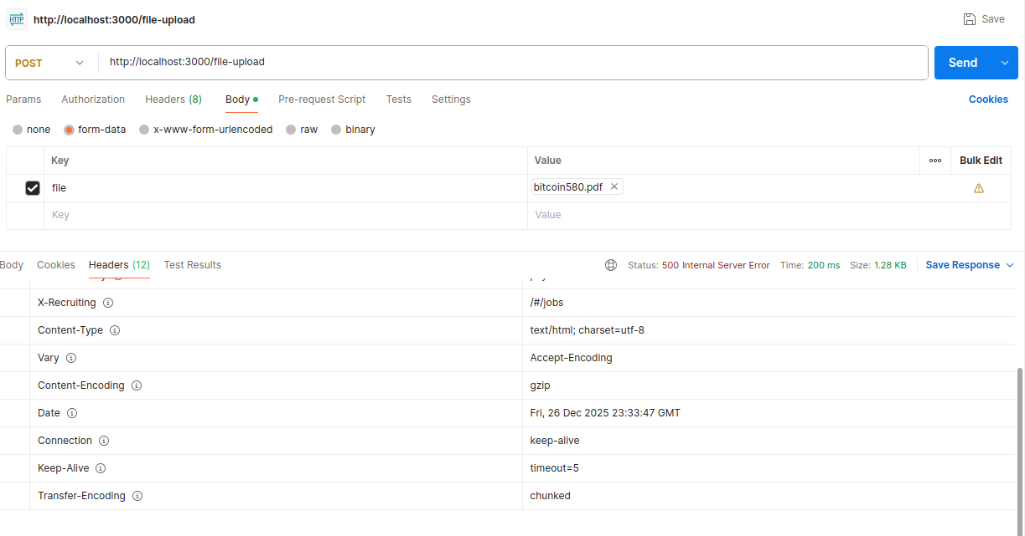
After sending the large file, the server crashes:

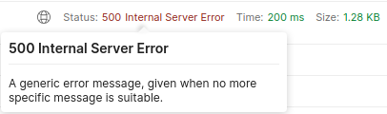
A well-designed application should reject large files gracefully, returning a clear status like:
- 413 Payload Too Large
- 400 Bad Request with a message like “File exceeds max size”
Returning 500 exposes a flaw:
- Server can crash or behave unpredictably
- Attackers can attempt Denial-of-Service (DoS) by sending very large files
- May leak stack traces, error messages, or other sensitive info

Broken Authentication:

Try to change the password. JuiceShop requires a security password when changing your password, but no email confirmation is required. Provide INVALID answer for security question:
Go logged in to: http://localhost:3000/#/forgot-password
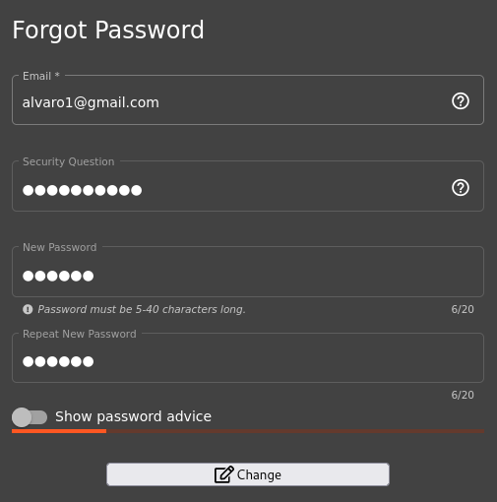
I needed to modify the UI so it allows adding text to the fields, just you need to remove the disabled=”” from every component (In DevTools), and now we can click on change and check the message sent.
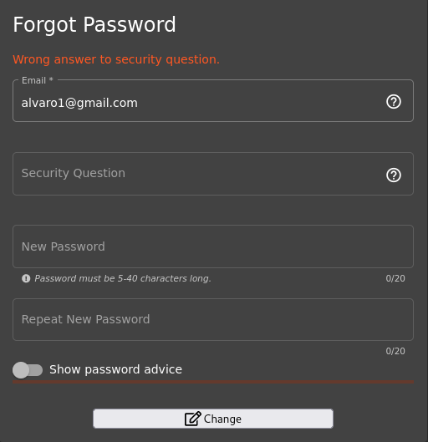

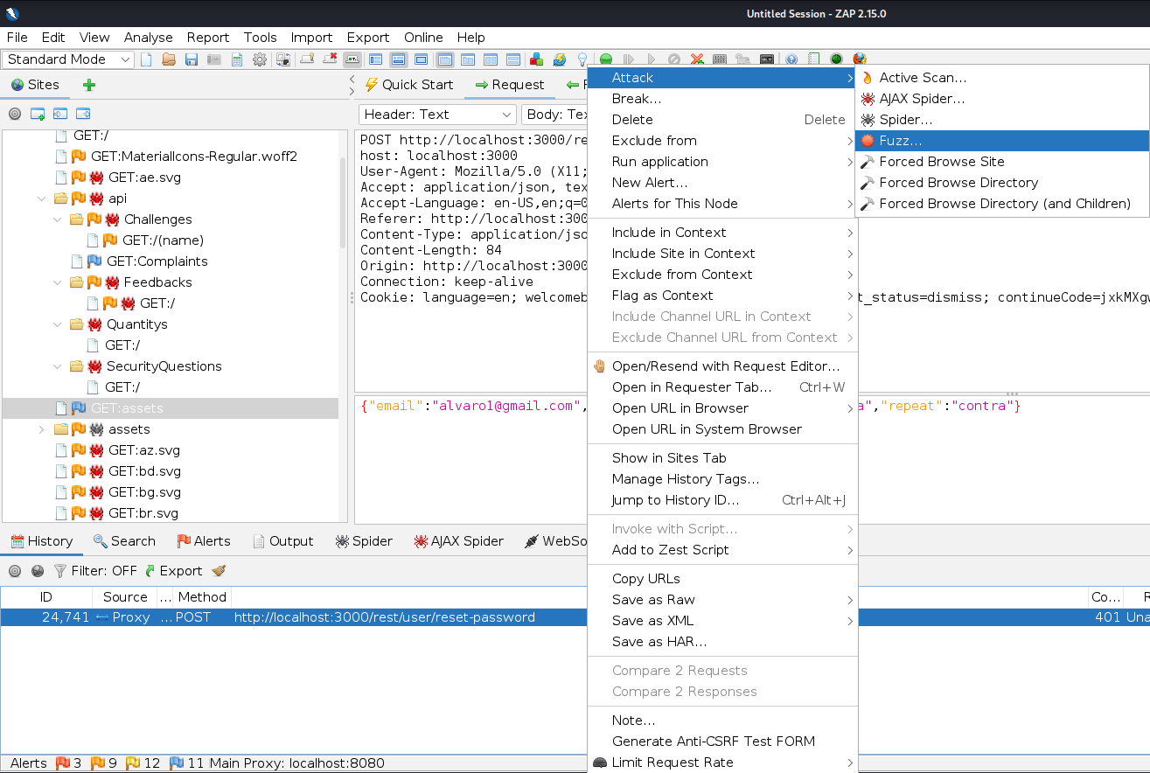
Find the request in ZAP and use option Fuzz…:

Select parts of date from answer and prepare rules for fuzzing (Add… -> Add -> Numberzz -> provide valid values for days, months, and years, limit values to a reasonable range, because JuiceShop is blocking too many requests):
Mark the days and Fuzz by 1 -> 31
Mark the months from 1 -> 12
And years from 1960 -> 2025

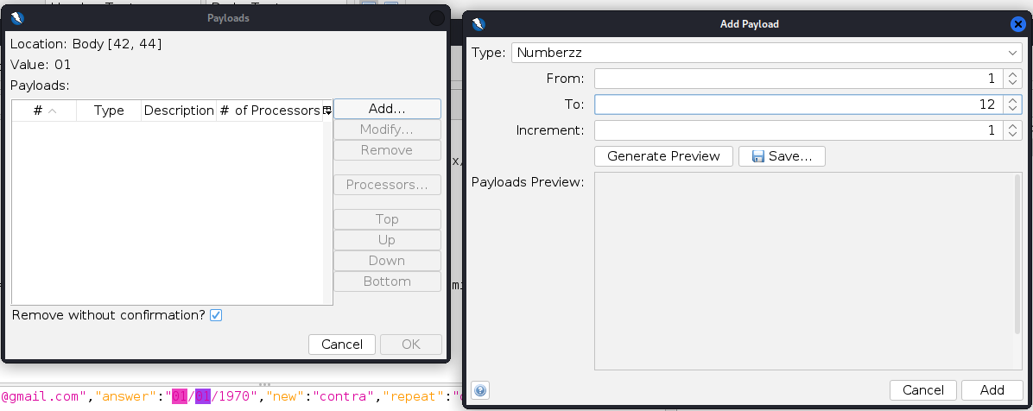
Here and example of the months:

And we start the attack:
As the range is too large, we get HTTP/1.1 429 Too Many Requests
We need to reduce the range: To the year 2005
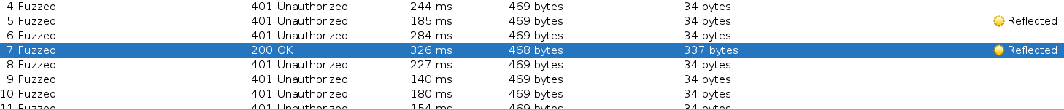

The app is vulnerable as it does not block the request after a limit is reached, neither sends an email to reset the password.

Broken Access Control:

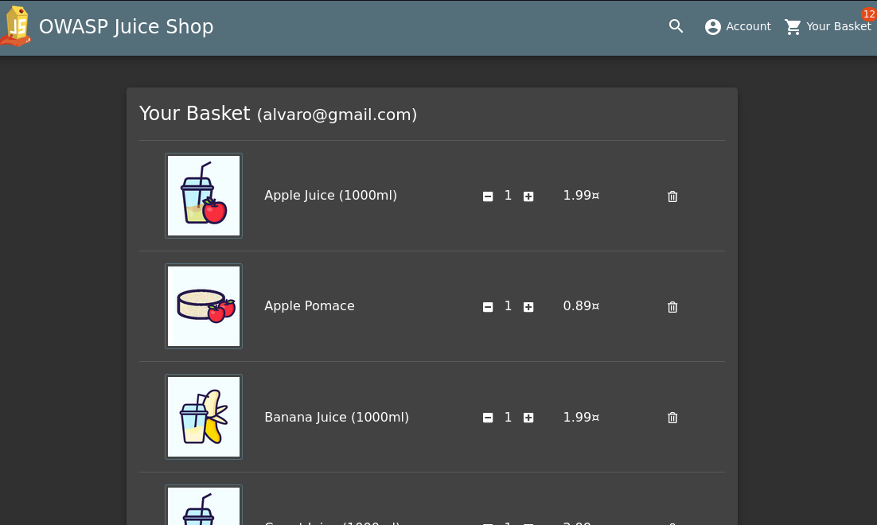
Add any products to your basket and open basket page:

Check the REST request in ZAP, it should contain id of your basket:
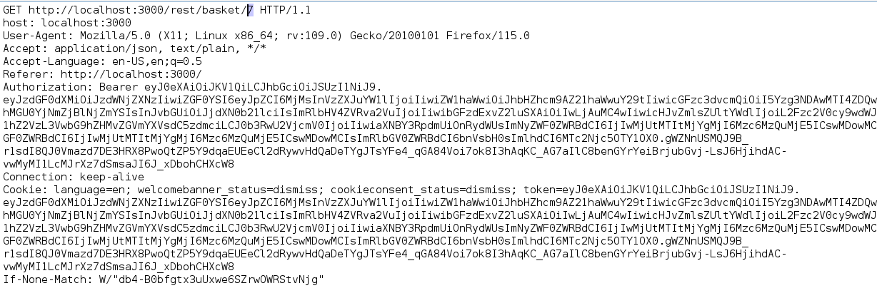
The id of the basket is 7:

Open JuiceShop in private browser window (or in any other browser), log in as other user and add products to basket:
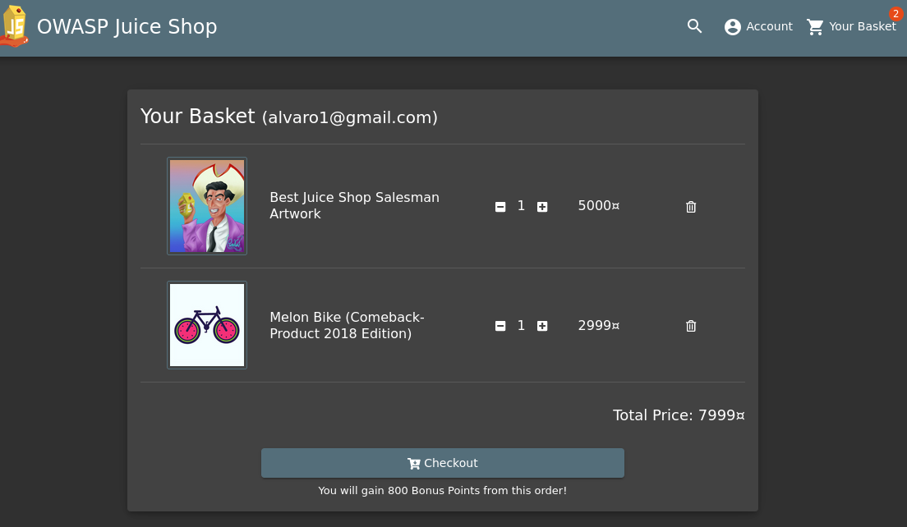

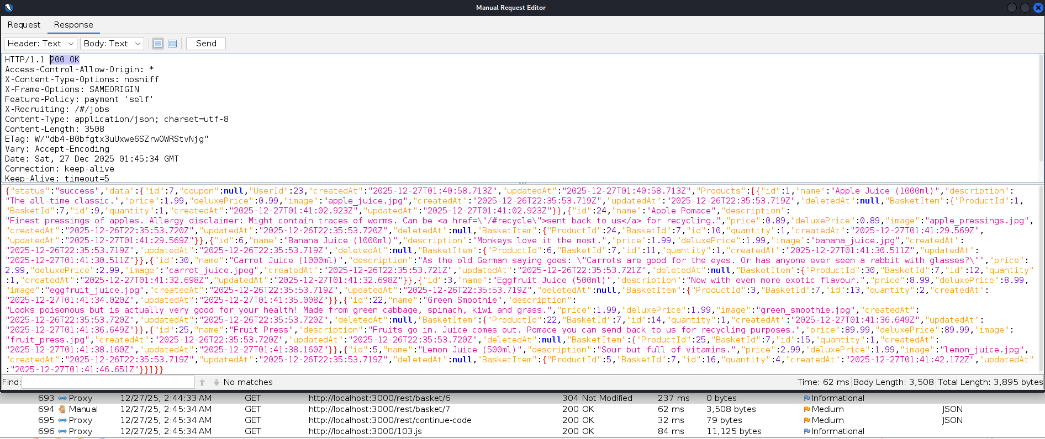
Edit request in Request Editor and change id of basket:

Check if you have an access to the basket as original use:
Yes, we have access to the basket 7 even if we are not user “alvaro”, this is a big problem of privacy.

By modifying the basket ID in the REST request, it was possible to access another user’s basket without authorization. This confirms an Insecure Direct Object Reference (IDOR) vulnerability, demonstrating Broken Access Control, as the application does not enforce ownership checks on basket resources.

